FOR IMMEDIATE RELEASE:
CONTACT: LCDR Neal Harper, USN
Combat Wounded Veteran Challenge, Inc.
Office: (727) 942-8415
neal.harper@combatwounded.org
www.CombatWounded.org

ST. PETERSBURG, FLORIDA, MAR. 1, 2016 – Combat Wounded Veteran Challenge, Inc. (“CWVC”), www.combatwounded.org, headquartered in St. Petersburg, FL, announced today that its Board of Directors, by unanimous decision, has elected Jay Kenneth Katzen as Chairman of the Board of Directors, effective immediately.
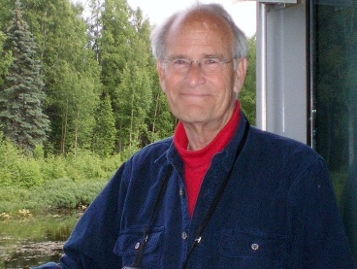
A retired career Foreign Service Officer, Jay Katzen served as Chief of Mission at several important embassies abroad. He now is a Park Ranger at Denali National Park and Preserve. Katzen was born in Brooklyn, NY, and received his B.A. (magna cum laude) in Political Science from Princeton University and an M.A. in International Relations from Yale University. He also attended the National War College in 1970. Katzen served under presidents Dwight D. Eisenhower through George H.W. Bush. His diplomatic posts included Australia, Burundi, Zaire, Romania, Mali, the U.S. Mission to the United Nations in New York, and Congo. In 1990, President Ronald Reagan appointed, and the U.S. Senate confirmed, Katzen as Vice Chairman of the Board of the African Development Foundation, a position he held for two years. Subsequently, our new Chairman served four terms in the Virginia State Legislature, was Chief of Staff of the Peace Corps, then President of the Victims of Communism Memorial Foundation.

The mission of CWVC is to improve the lives of our wounded or injured veterans by assisting them in realizing their newfound potential by providing “Challenge” expeditions that are physically and psychologically demanding and requiring extreme outdoor efforts. These rehabilitative high adventure and therapeutic expeditions, led by veterans, provide sufficiently arduous, reasonably achievable, and extremely motivational experiences. While participating in these grueling Challenges, the veterans also voluntarily participate in field work and case studies that furthers medical, physiological, biomedical and pathological sciences associated with their injuries. These field work and studies are helping to produce gains in the fields of traumatic brain injuries, post-traumatic stress, orthotics and prosthetics.

The Challenge teams are tested mentally and physically in extreme conditions. If the wounded or injured veterans can literally and figuratively “climb a mountain,” then the goal of transitioning becomes less daunting and more attainable. The camaraderie of again being part of a team … a mission with objectives … achieving success … giving wounded and injured veterans the confidence to seek assistance and know they are not alone.

Members of the CWVC Board of Directors include Jay Katzen, CAPT Dominic Gorie, USN, (Ret), a retired NASA astronaut and veteran of four space shuttle missions, CAPT David Olson, USN (Ret), the founder of CWVC, LCDR Gerard Coleman, USN (Ret), a professor of Marine Engineering Technology at Texas A&M University, and Ben J. Hayes, J.D., an attorney and former Major League Baseball pitcher.

